Lab 1

configuring Windows Server 2016

This lab contains the following exercises and activities:

|  |  |
| --- | --- |
| Exercise 1.1 | Configuring Windows Server 2016 |
| Exercise 1.2 | Configuring IPv4 Settings |
| Exercise 1.3 | Configuring IPv6 Settings |
| Lab Challenge | Using Server Manager and Computer Management |

BEFORE YOU BEGIN

The lab environment consists of student workstations connected to a local area network, along with a server that functions as the domain controller for a domain called adatum.com. The computers required for this lab are listed in Table 1-1.

Table 1-1

Computers required for Lab 1

|  |  |  |
| --- | --- | --- |
| Computer | Operating System | Computer Name |
| Server (VM 1) | Windows Server 2016 | LON-DC1 |
| Server (VM 2) | Windows Server 2016 | LON-SVR4 |

In addition to the computers, you will also require the software listed in Table 1-2 to complete Lab 1.

Table 1-2

Software required for Lab 1

|  |  |
| --- | --- |
| Software | Location |
| Lab 1 student worksheet | Lab01_worksheet.doc (provided by instructor) |

Working with Lab Worksheets

Each lab in this manual requires that you answer questions, shoot screen shots, and perform other activities that you will document in a worksheet named for the lab, such as Lab01_worksheet.doc. You will find these worksheets on the book companion site. It is recommended that you use a USB flash drive to store your worksheets, so you can submit them to your instructor for review. As you perform the exercises in each lab, open the appropriate worksheet file using Word, fill in the required information, and save the file to your flash drive.

SCENARIO

After completing this lab, you will be able to:

* Use Control Panel and Windows Server 2016 Settings to configure Windows.
* Configure IPv4 settings
* Configure IPv6 settings
* Use Server Manager and Computer Management to configure Windows.

Estimated lab time: 75 minutes

|  |  |
| --- | --- |
| Exercise 1.1 | Configuring Windows Server 2016 |
| Overview | In this exercise, you will configure Windows Server 2016 using Windows Server 2016 Settings and Control Panel. |
| Mindset | When you click the Settings option, you launch the Settings application that is based on the Modern UI interface to access common settings. In previous versions of Windows, the Control Panel was the primary graphical utility to configure the Windows environment and hardware devices. |
| Completion time | 20 minutes |

1. Log on to **LON-SRV4** as **adatum\administrator** with the password of **Pa$$w0rd**.
2. Click the **Start** button and then click **Settings**. The Settings window opens as shown in Figure 1-1.

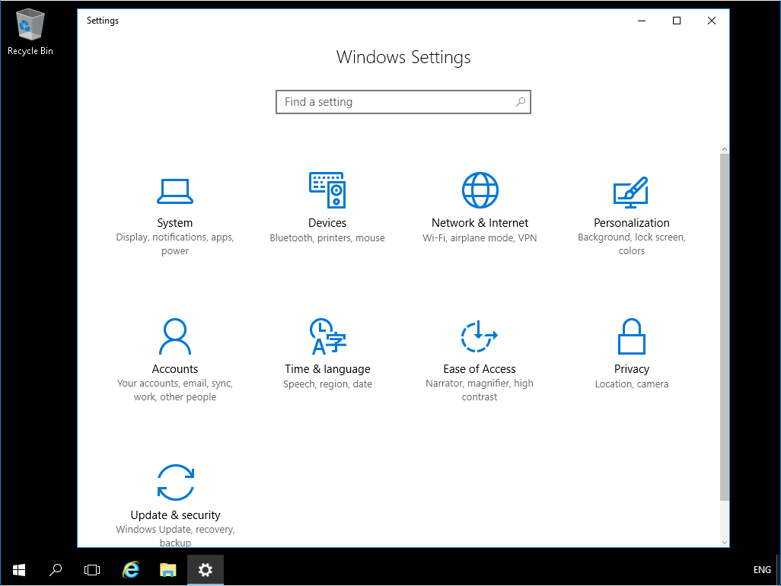

Figure 1-1

Windows Server 2016 Settings

1. Click the **Personalization** option.
2. On the Personalizatin page, click **Start**.
3. Scroll down and click the **Choose which folders appear on Start** option.
4. Click the **Start** button and see whether Documents and Downloads are listed.
5. Click the **Start** button again to close the Start page.
6. Click the **Documents** option and the **Downloads** option, so that the settings is set to **On**.
7. Click the **Start** button. Notice the two icons above the gear button.
8. 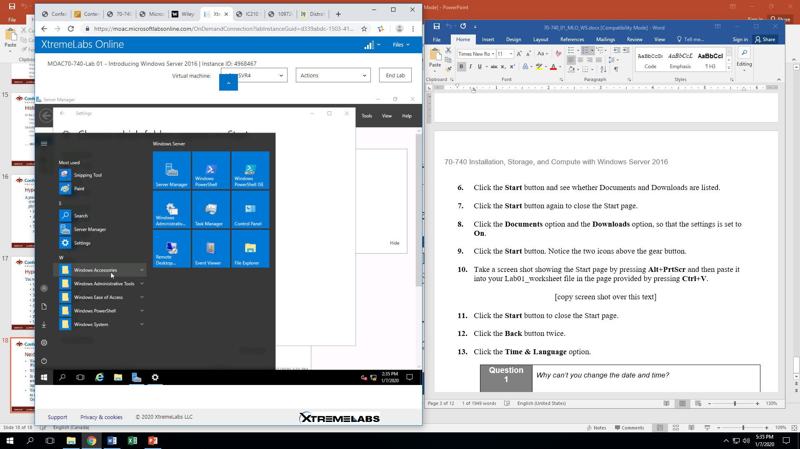Take a screen shot showing the Start page by pressing **Alt+PrtScr** and then paste it into your Lab01_worksheet file in the page provided by pressing **Ctrl+V**.
9. Click the **Start** button to close the Start page.
10. Click the **Back** button twice.
11. Click the **Time & Language** option.

|  |  |
| --- | --- |
| Question 1 | Why can’t you change the date and time?  Because some settings are managed by your organization. |

1. Close the **Settings** window.
2. Right-click the **Start** button and choose **Control Panel**.
3. If the Control Panel is showing large or small icons, change the View by option to **Category**.
4. Click the **System and Security** option.
5. Click **System**.

|  |  |
| --- | --- |
| Question 2 | How much RAM does your system have?  2 GB |

1. At the top of the window, click **Control Panel Home**.
2. Under Hardware, click **View devices and printers**.

|  |  |
| --- | --- |
| Question 3 | How many printers are installed?  2 |

1. At the top of the window, click **Control Panel**.
2. Under Clock, Language, and Region, and click **Set the time and date** link.

|  |  |
| --- | --- |
| Question 4 | Which time zone is the computer using?  Pacific Time |
| Question 5 | Is the date and time correct?  Yes, if we are in Pacific time |

1. In the Date and Time dialog box, click the **Change date and time** button.
2. In the Date calendar, click tomorrow’s date and click **OK**.
3. 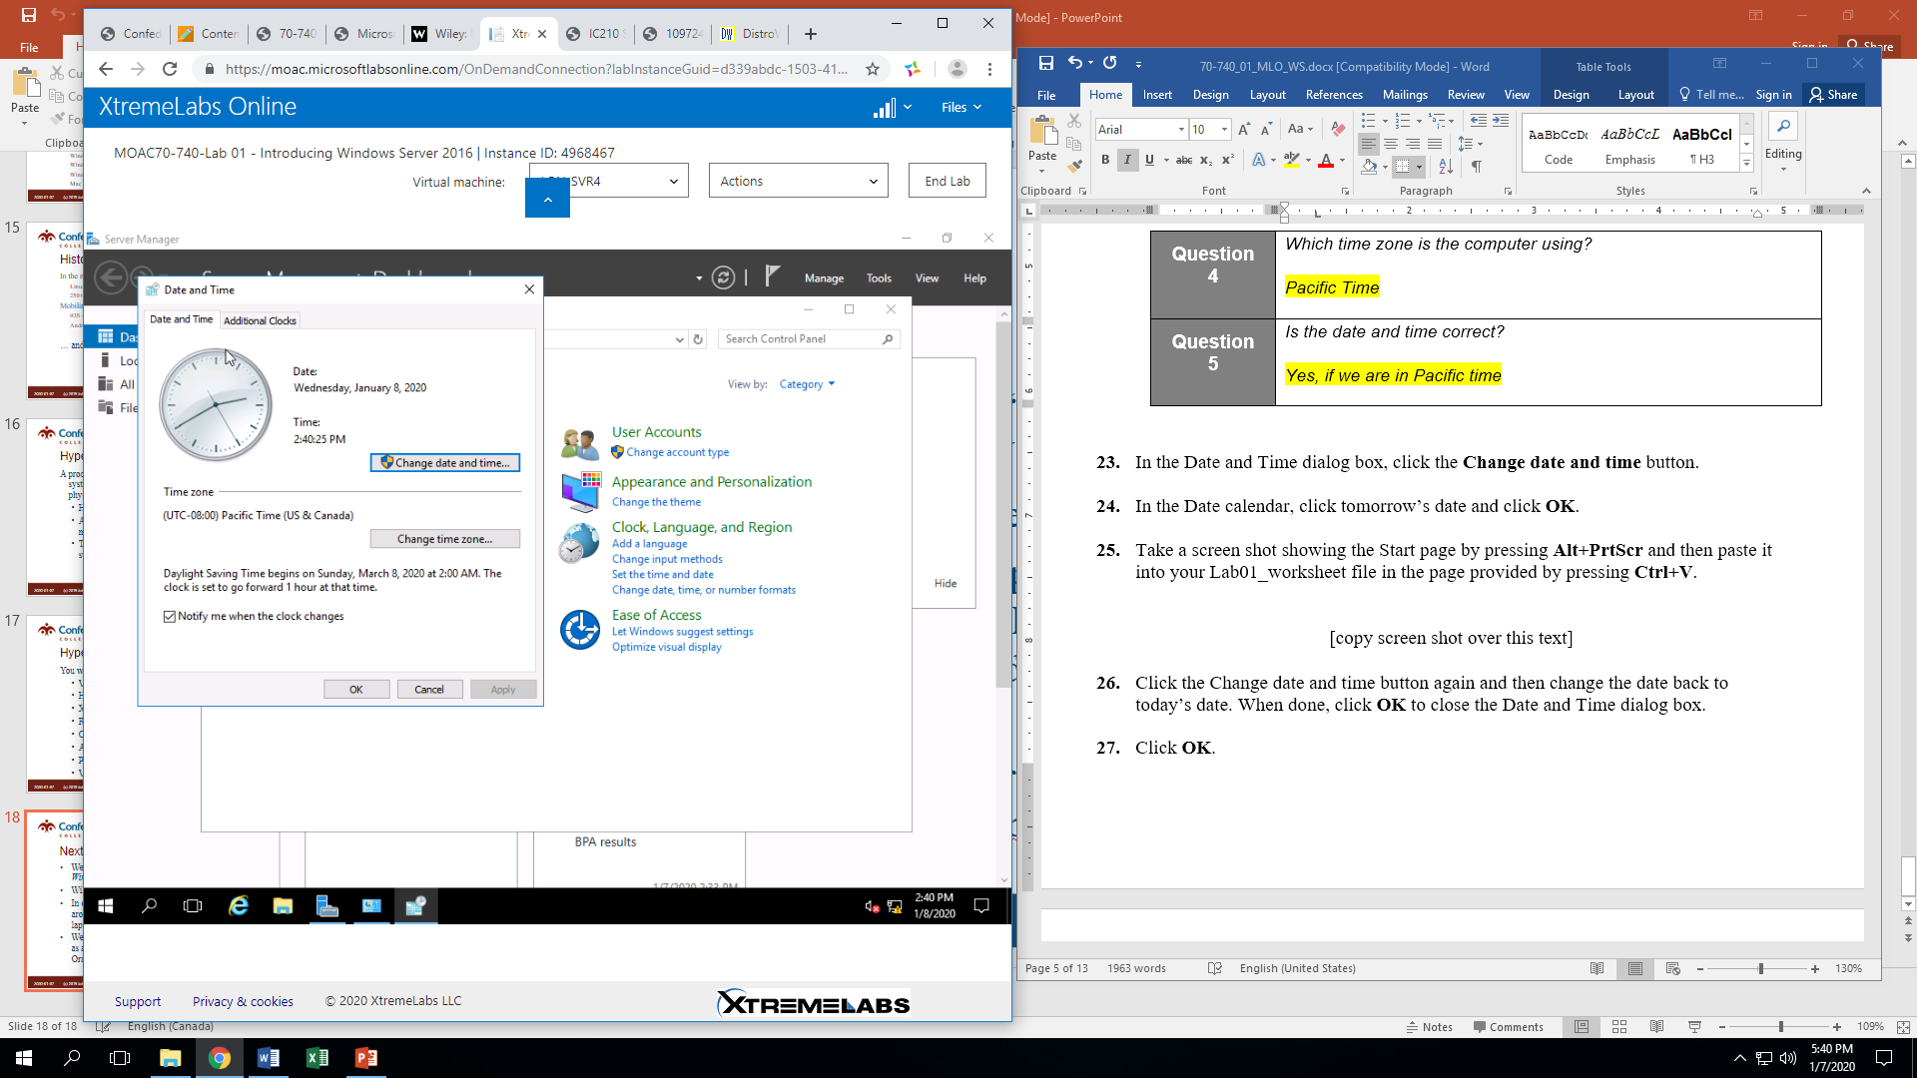Take a screen shot showing the Start page by pressing **Alt+PrtScr** and then paste it into your Lab01_worksheet file in the page provided by pressing **Ctrl+V**.
4. Click the Change date and time button again and then change the date back to today’s date. When done, click **OK** to close the Date and Time dialog box.
5. Click **OK**.

Remain logged on to LON-SVR4 for the next exercise.

|  |  |
| --- | --- |
| Exercise 1.2 | Configuring IPv4 Settings |
| Overview | In this exercise, you will configure IPv4 settings, including enabling a DHCP address and manually configuring the IPv4 settings. |
| Mindset | Network settings can be configured either manually or automatically using DHCP. When using manual settings, you can unknowingly introduce configuration issues that can affect communications. Using a centralized approach to IP address management requires you to have a solid understanding of DHCP. |
| Completion time | 20 minutes |

1. Log on to **LON-SVR4** as **adatum\administrator** with the password of **Pa$$w0rd**.
2. On **LON-LON-SVR4**, right-click the **Start** button and choose **Control Panel**.
3. In the Control Panel, click **Networking and Internet > Network and Sharing Center**. The Network and Sharing Center page opens as shown in Figure 1-2.

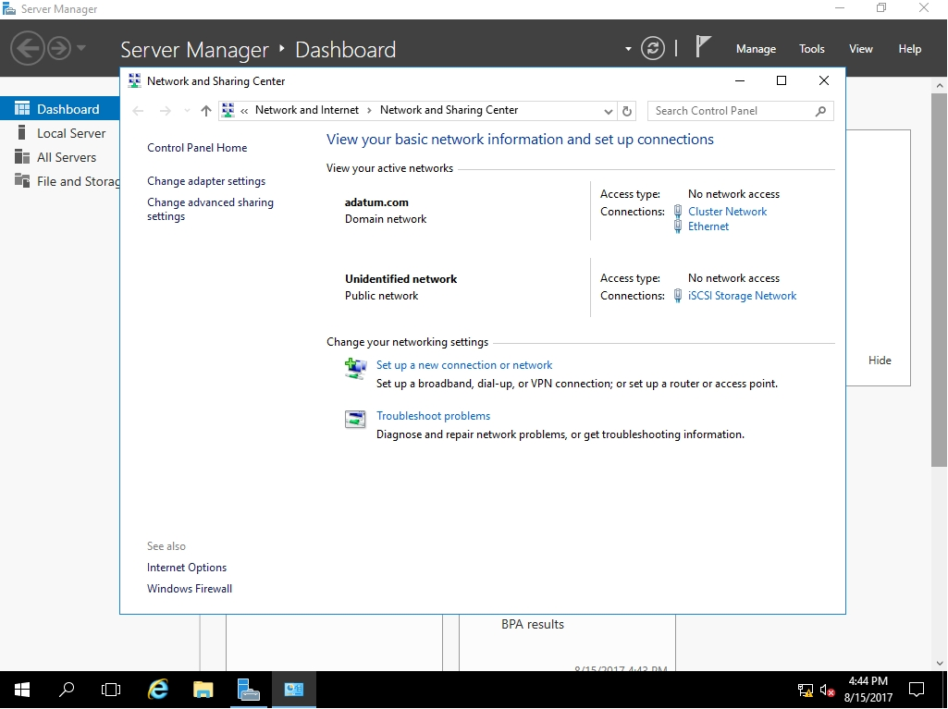

Figure 1-2

The Network and Sharing Center page

1. On the Network and Sharing Centerpage, click **Change adapter settings**.
2. Double-click the **Ethernet** icon.
3. In the Ethernet Statusdialog box, click **Properties**.
4. In the Ethernet Propertiesdialog box, scroll down and double-click **Internet Protocol Version 4 (TCP/IPv4)**.

|  |  |
| --- | --- |
| Question 6 | What is the current IP address configuration for the Ethernet adapter Ethernet connection?  IP Address: 172.16.0.24  Subnet mask: 255.255.0.0  Default gateway: 172.16.0.1  Preferred DNS server: 172.16.0.10 |

1. Select the **Obtain an IP address automatically** option. Then Select the **Obtain DNS server address automatically** option. Click **OK**.
2. Close the Ethernet Properties dialog box by clicking **OK**.
3. Close the Ethernet Status dialog box by clicking **Close**.
4. Click the **Start** button, type **cmd**, and then press the **Enter** key.
5. At the command prompt, execute the **ipconfig** command.

|  |  |
| --- | --- |
| Question 7 | What is the current IP address configuration for Ethernet adapter Ethernet connection?  IP Address: 172.16.0.160  Subnet mask: 255.255.255.0  Default gateway: 172.16.0.1 |

1. At the command prompt, execute the **ipconfig /all** command.

|  |  |
| --- | --- |
| Question 8 | How do you know that this address for Ethernet adapter Ethernet was assigned by a DHCP server?  Because DHCP enabled reads “Yes” and DHCP Server reads “172.16.0.10” |
| Question 9 | The default gateway could be assigned to any local IP address. Which address range could be assigned to the Default gateway to indicate a local router? Because the subnet mask is 255.255.255.0 which indicates that the IP address for the default gateway can be between 172.16.0.1 to 172.16.0.254 |

1. Return to the **Network and Sharing Center** window and double-click the **Ethernet** adapter.
2. In the Ethernet Status dialog box, click the **Properties** button.
3. Double-click the **Internet Protocol Version 4 (TCP/IPv4)**.
4. In the Internet Protocol Version 4 (TCP/IPv4) Properties dialog box, select **Use the following IP address**.
5. Specify the following information:

IP address: **172.16.0.24**

Subnet mask: **255.255.255.0**

1. Select the **Use the following DNS server addresses** option.

Preferred DNS server: **172.16.0.10**

1. Close the Internet Protocol Version 4 (TCP/IPv4) Properties dialog box by clicking **OK**.
2. Close the Ethernet Properties dialog box by clicking **OK**.
3. Close the Ethernet Status dialog box by clicking **Close**.
4. Return to the command prompt window and execute the **ipconfig** command:
5. 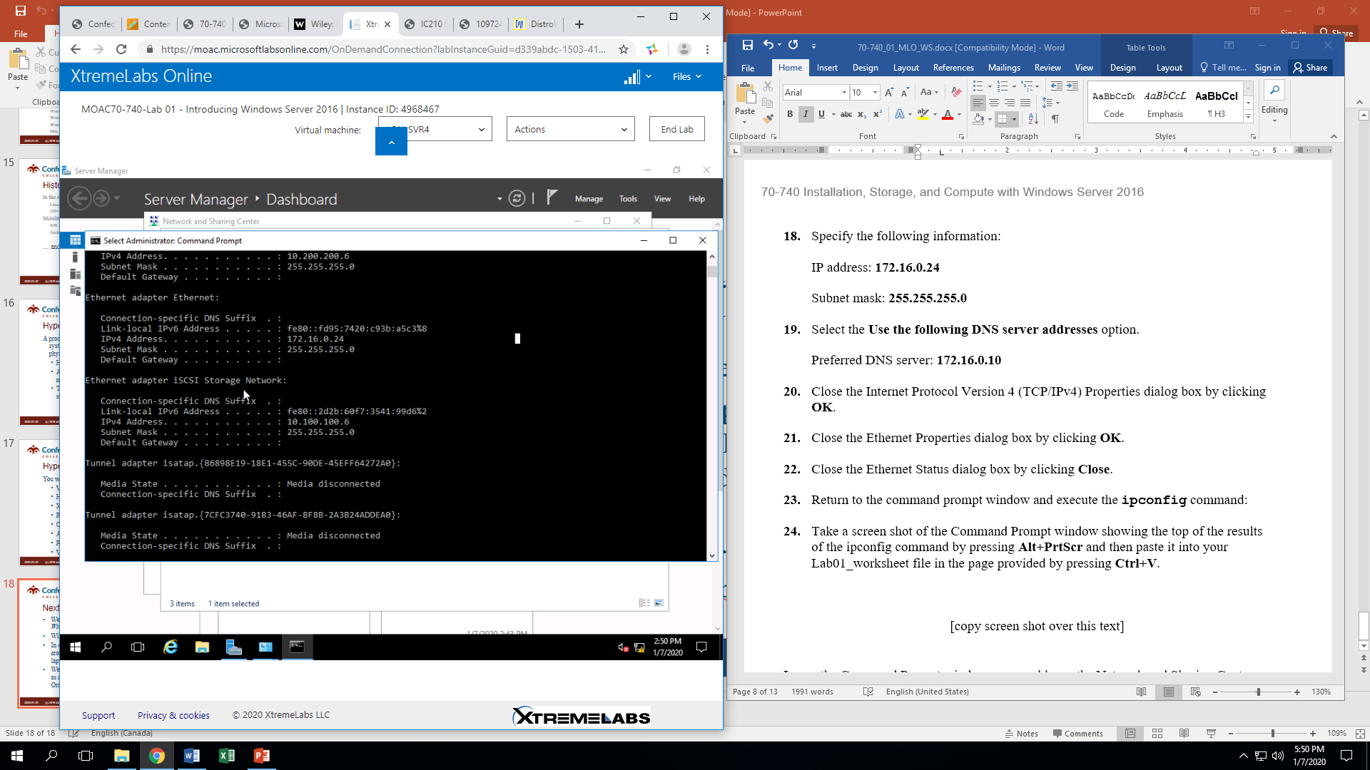Take a screen shot of the Command Prompt window showing the top of the results of the ipconfig command by pressing **Alt+PrtScr** and then paste it into your Lab01_worksheet file in the page provided by pressing **Ctrl+V**.

Leave the Command Prompt window open and leave the Network and Sharing Center open for the next exercise.

|  |  |
| --- | --- |
| Exercise 1.3 | Configuring IPv6 Settings |
| Overview | In this exercise, you will configure IPv6 settings. |
| Mindset | To overcome this problem of running out of IPv4 addresses, as well as a few others, IPv6 was developed as the next-generation Internet Protocol version. Because IPv6 uses 128 bits, the addresses are usually divided into groups of 16 bits, written as 4 hex digits. |
| Completion time | 10 minutes |

1. On **LON-SVR4**, using Network and Sharing Center, click **Ethernet**.
2. In the Ethernet Properties dialog box, click the **Details** button.
3. In the Network connections Details dialog box, answer the following question and then click **Close**.

|  |  |
| --- | --- |
| Question 11 | What is the Link-local IPv6 address? fe80:fd95:7420:c93b:5c3%8 |

1. In the Ethernet Status dialog box, click the **Properties** button.
2. In the Ethernet Properties dialog box, scroll down and double-click **Internet Protocol Version 6 (TCP/IPv6)**, as shown in Figure 1-3. The Internet Protocol Version 6 (TCP/IPv6) Properties dialog box opens.

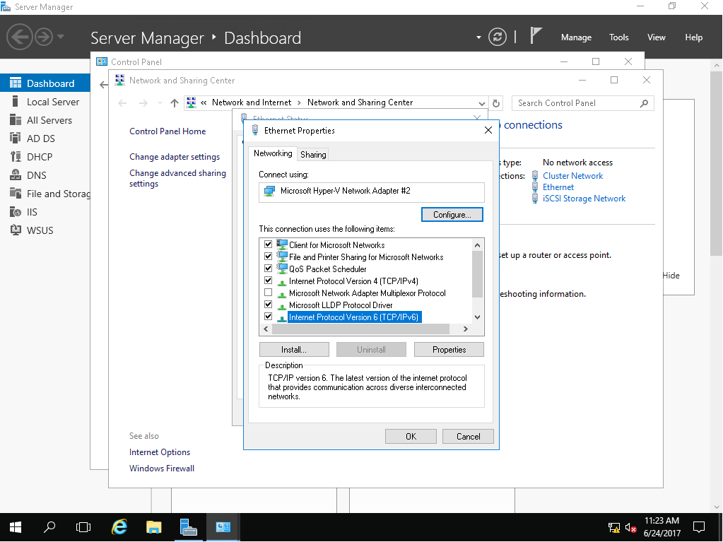 f

Figure 1-3

Opening Internet Protocol Version 6 (TCP/IPv6) properties

1. Select **Use the following IPv6 address**.
2. Type the following and then click **OK**.

IPv6 address: **fe80:0:ac4a:aa04:713a:0:0:ce2b**

Subnet prefix length: **64**

1. Close the Internet Protocol Version 6 (TCP/IPv6) Properties dialog box by clicking **OK**.
2. Close the Ethernet Status dialog box by clicking **Close**.
3. Go back to the command window and execute the **ipconfig** command.
4. 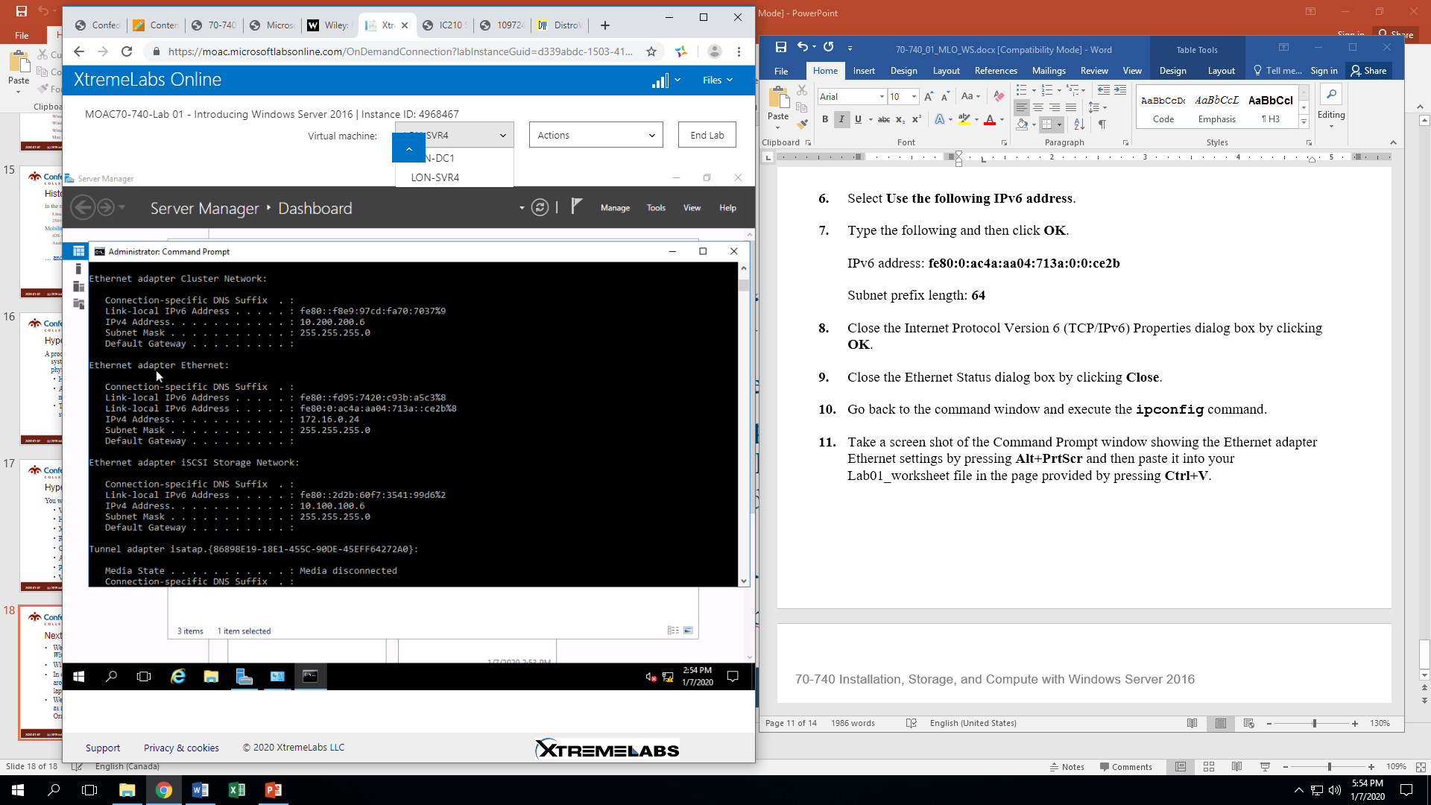Take a screen shot of the Command Prompt window showing the Ethernet adapter Ethernet settings by pressing **Alt+PrtScr** and then paste it into your Lab01_worksheet file in the page provided by pressing **Ctrl+V**.

Close all windows on LON-SVR4 before continuing to the Lab Challenge.

|  |  |
| --- | --- |
| Lab Challenge | Using Server Management and Computer Management |
| Overview | In this exercise, you will use Server Manager and Computer Management to configure your computer. You will use Comptuer Management to create a local user and you will use Server Manager to access various tools. |
| Mindset | Computer Management manages local or remote computers by using a single, consolidated desktop tool. Using Computer Management, you can perform many tasks, such as monitoring system events, configuring hard disks, managing system performance, managing users and groups, and managing shared folders. Server Manager allows you to install, configure, and manage Windows Server 2016 server roles and features. |
| Completion time | 25 minutes |

1. On **LON-SVR4**, right-click the **Start** button and choose **Computer Management**.
2. In the Computer Management console, expand **Local Users and Groups** and click **Users**, as shown in Figure 1-4.

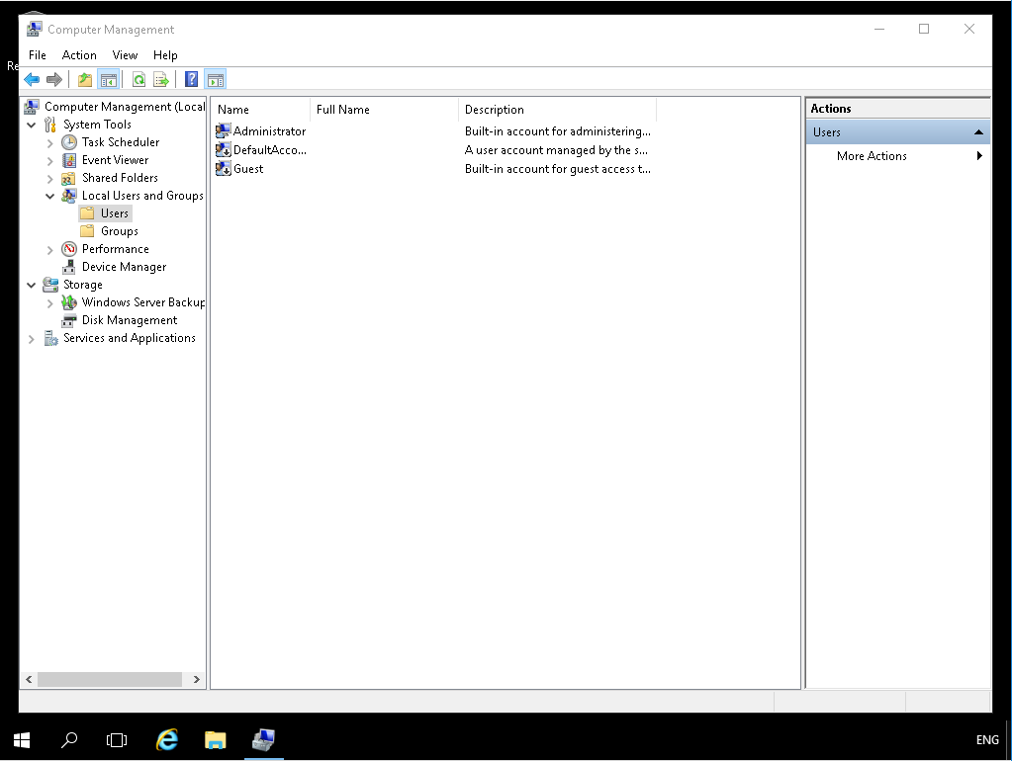

Figure 1-4

Opening Internet Protocol Version 6 (TCP/IPv6) properties

1. Right-click the **Users** node and choose **New User**.
2. In the User name text box, type **User1**. In the Full name text box, type **User 1**.
3. In the Password text box and the Confirm password text box, type **Pa$$w0rd**.
4. Click the **Create** button.
5. To close the New User dialog box, click **Close**.
6. In Computer Management, expand the **Event Viewer** node, expand the **Windows Logs**, and then click **System**.
7. If there are any warnings or errors on the screen, click each warning and error on the screen.

|  |  |
| --- | --- |
| Question 12 | Which warnings and errors are indicated?  Time Service Warning  DNS Client Warning |

1. Click the **Application** node. Review some of the warnings and errors.
2. Click the **Device Manager** node. Expand some of the nodes to see which devices are used by the system.
3. Expand the **Services and Applications** node and then click **Services**.
4. Close the Computer Management window.
5. Click the **Start** button and then click **Server Manager**.
6. In Server Manager, click **Local Server**.

|  |  |
| --- | --- |
| Question 13 | Which domain is this system a member of?  Adatum.com |

1. In the Properties section, scroll to the bottom of the list.

|  |  |
| --- | --- |
| Question 14 | Which processor is used in the system? Intel Xeon CPU E5640 @ 2.67GHz |

1. Click **Tools >** **Computer Management**.
2. Close the Computer Management window.
3. Click **Tools** **>** **Event Viewer**.
4. 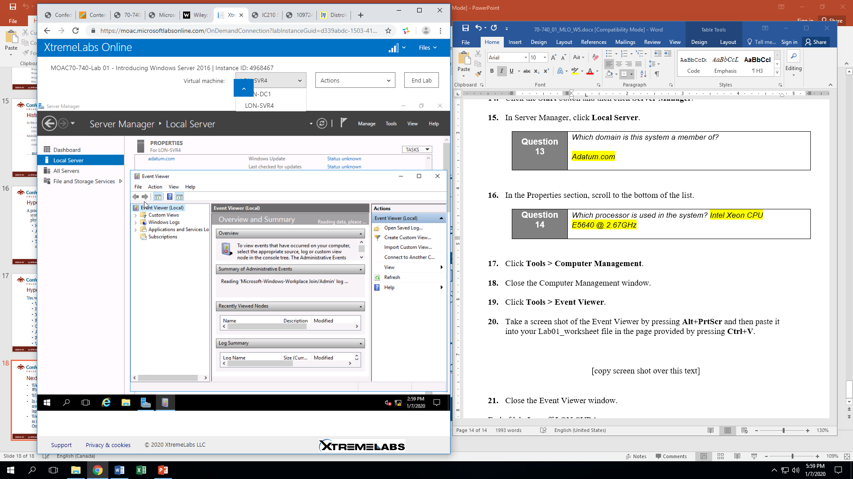Take a screen shot of the Event Viewer by pressing **Alt+PrtScr** and then paste it into your Lab01_worksheet file in the page provided by pressing **Ctrl+V**.
5. Close the Event Viewer window.

End of lab. Log off LON-SVR4.